# Evidence on sectoral variation in carbon prices

## Published sources

### Taxing Energy Use (OECD, 2018)

* Aggregated effective tax rates on energy use in 42 OECD and G20 economies in EUR/tCO2 (2015)
* Rates are given by sector, by fuel, and include carbon taxation, fuel and energy taxation and credits
* Note that it looks like ETS prices are excluded from effective tax rate estimates – suggest we add these back in by finding ETS prices by OECD and G20 economy from STCP work, and adding in country weighted average ETS prices

1. Average effective tax rates on energy use (EUR/tCO2 in 2015) across 42 OECD and G20 economies, by sector and by fuel

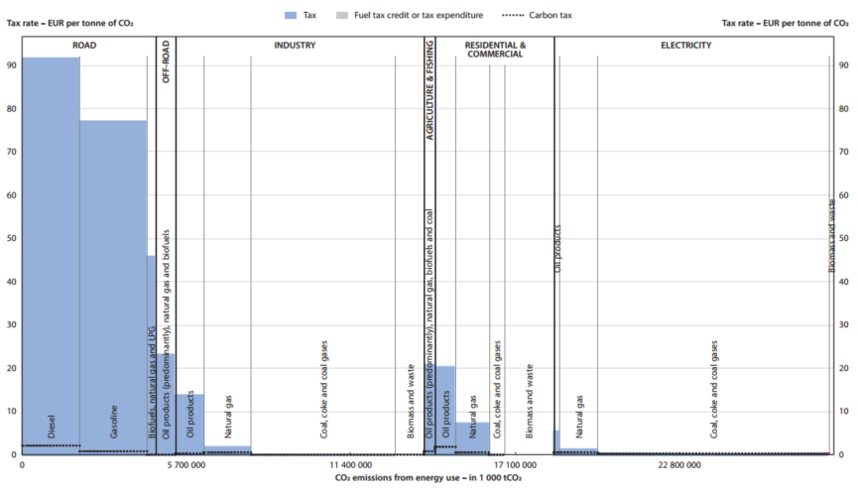

Note: Excluding taxes on electricity output, including carbon emissions from biomass

Source: Page 35 (33/58) of Taxing energy use 2018, OECD

### Effective Carbon Rates (OECD, 2016)

* Effective tax rates on energy use in 41 countries, by country in EUR/tCO2 (2012)
* Rates are given by sector, by fuel, and include all taxes and emissions trading schemes
* These estimates are older, so the Taxing Energy Use source is preferred, but the estimates of ETS prices by country could be useful

1. Average effective tax rate on energy use in 41 economies, by sector and components (ETS vs. tax)

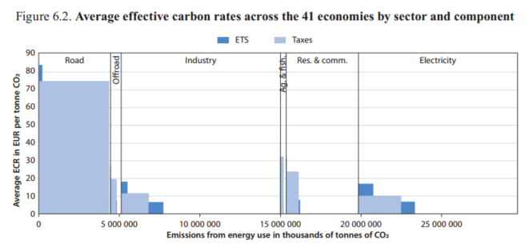

Note: Within each industry, shaded areas represent the volume of CO2 emissions from energy use subject to a given price; for instance, in industry, the vast majority of emissions in the countries in question are not subject to any pricing, a very small proportion are subject to just an ETS, a small proportion are subject to just taxes, and a very small proportion are subject to both taxes and an ETS

Source: Page 85 of Effective Carbon Rates 2016, OECD

### States and trends in carbon pricing (World Bank, 2017)

* Carbon taxes and ETS scheme prices by region
* Does not include fuel and energy taxes
* Does not provide effective carbon prices by sector, or a sectoral breakdown of prices

1. Carbon price and emissions coverage of implemented carbon pricing initiatives



Note: This excludes fuel and energy taxes, and does not provide a sectoral breakdown of prices

Source: Pages 29 (31/104) and 44 (46/104) of States and Trends in Carbon Pricing 2017, World Bank Group

## Specific country examples

### France and Norway

* Carbon tax on fossil fuels not in the EU ETS

### Sweden

* Carbon tax on industries outside the EU ETS

### California

* Low carbon fuel standard overlaps with ETS covering transport fuel sales

### EU ETS

* Renewable energy directive (RED) and the Fuel quality directive (FQD) also overlap with EU ETS and result in different implicit carbon price in the transport sector

### British Columbia

* Operates carbon tax covering transport fuels in parallel with a motor fuel tax and biofuel blending mandates